Coursework Part A: Conceptual EERD

Database Systems

Name: Om Sadigale

ID: W1943544

Day of Tutorial: Wednesday

Time of Tutorial: 9am – 11am

Part A: Question1

1. Business Questions:

To gain more insight, I would like to frame few questions. Please share your thoughts.

1. Are there any activities available for disabled guests?
2. Is it allowed for guests to book a fully integrated apartment and a standalone room together?
3. Are there more activates available except the ones mentioned?
4. Will allergies be considered when preparing a meal for the guests?
5. Is it mandatory to store data regarding the method of payment while booking?
6. Done
7. Screenshot of Coursework Q&A with Board of Director:

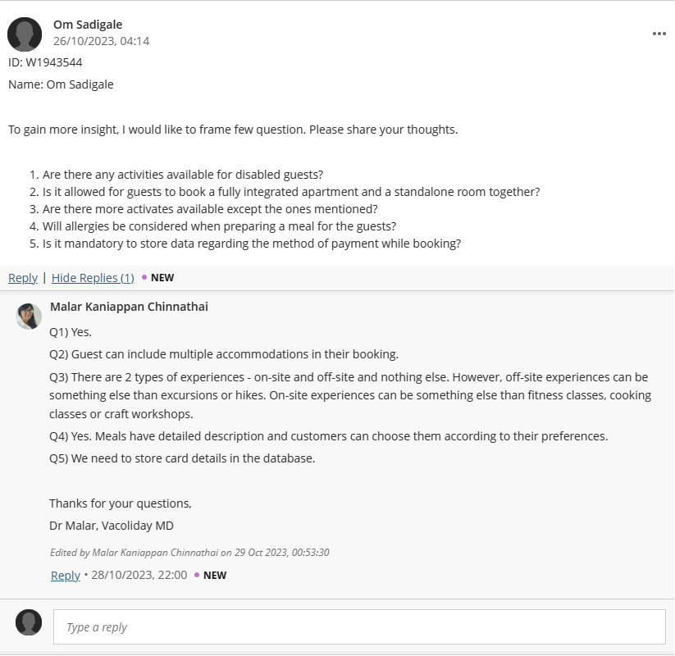

1. Reflective Commentary:

* Got a deeper understanding of the experience available for the guests with disability.
* This helps in understanding the specialisation constraints in accommodation.
* Aids in understanding the bounding of experience available for the guests.
* Gained information regarding the precautions taken while booking a meal for the guests.
* To information regarding the data stored while of payments made while booking

Part A: Question 2

1. Entities for Vacoliday:

* w1943544_Residence
* w1943544_Accommodation
* w1943544_Meal
* w1943544_Experience
* w1943544_Staff
* w1943544_Guest
* w1943544_Payment

1. Entity Data Dictionary Table:

|  |  |
| --- | --- |
| *Entity name* | *Description* |
| w1943544_Residence | List of Residences around Vacomedita |
| w1943544_Accommodation | The list of accommodations available for reservation. |
| w1943544_Meal | Various meals served by chefs from Vacoliday. |
| w1943544_Experience | A term used to describe on site/off site experiences the customers can book. |
| w1943544_Staff | A term used to describe all the staff members of Vacoliday. |
| w1943544_Guest | Regarding the people who making reservations in Vacoliday. |
| w1943544_Payment | Payment Transactions are stored for meal booking, reservation and activity booking |

Question 3:

1. Specialisation:

* w1943544_Apartments
* w1943544_Stand_Alone_Room
* w1943544_OnSite
* w1943544_OffSite
* w1943544_Attendant
* w1943544_Chef
* w1943544_Instructor
* w1943544_Driver
* w1943544_Guide

1. Specialisation Data Dictionary Table

|  |  |  |
| --- | --- | --- |
| *General Entity* | *Specialisation Entity* | *Description* |
| w1943544_Accommodation | w1943544_Apartment | Large Fully integrated apartments containing one or more bedrooms including rooms such as kitchen, bathroom, washing room, dining room and lounges. |
| w1943544_Stand_Alone_Room | Contains one bedroom with possibly an en-suite bathroom. |
| w1943544_Experience | w1943544_OnSite | Guests can participate in activities provided in residences such as cooking, fitness and craft classes. |
| w1943544_OffSite | Experiences which take outside the residence such as hiking and excursions |
| w1943544_Staff | w1943544_Attendant | Responsible for the maintenance of accommodation. |
| w1943544_Chef | Responsible for cooking meals and teaches cooking classes |
| w1943544_Instructor | There are 2 types of instructors: fitness and craft. They are responsible for leading OnSite classes. |
| w1943544_Driver | Responsible for accompanying people for excursions |
| w1943544_Guide | Oversees all the OffSite experiences |

Part A: Question 4: Relationships & Multiplicities

1. Relationship: (Bold main entites)

|  |  |  |  |  |  |
| --- | --- | --- | --- | --- | --- |
| Entity name | Multiplicity | Relationship | Multiplicity | Entity name | Brief justification |
| **w1943544_Residence** | 1..1 | has | 1..* | **w1943544_Accommodation** | One Residence must have at least one accommodation |
| One Residence can have many accommodations |
| One Accommodation must be in at least one Residence |
| One Accommodation can be in at most one Residence |
| w1943544_Collective_Meal | 0..* | is served | 1..1 | **w1943544_Residence** | One collective meal is served in at least one Residence |
| One collective meal is served in at most one Residence |
| One Residence may not have any Collective meals |
| One Residence can have many collective meals |
| w1943544_OnSite | 0..* | is conducted in | 1..1 | **w1943544_Residence** | One OnSite experience is conducted in at least one Residence |
| One OnSite experience is conducted in at most one Residence |
| One residence may not have any OnSite experiences. |
| One residence can have many OnSite experiences. |
| w1943544_Attendant | 1..* | is allocated to | 1..1 | **w1943544_Accommodation** | One Attendant is allocated at least One Accommodation |
| One Attendant can be allocated to at most One Accommodation |
| One Accommodation is managed by at least one Attendant |
| One Accommodation can be managed by many Attendants |
| w1943544_Delivery | 0..* | delivered | 1..1 | **w1943544_Accommodation** | One Delivery is delivered to at least one Accommodation |
| One Delivery is delivered to at most one Accommodation |
| One Accommodation may not have any Delivery |
| One Accommodation can have many Deliveries |
| w1943544_Reservation | 0..1 | has | 1...* | **w1943544_Accommodation** | Each Reservation may have at least one accommodation |
| One Reservation can have many Accommodations |
| One Accommodation may have no Reservation |
| One Accommodation may have at most one Reservation |
| **w1943544_Guest** | 1..1 | makes | 1..* | w1943544_Reservation | One guest must make at least one reservation |
| One guest can make many reservations |
| One reservation must have at least one guest |
| One reservation has at most one guest |
| **w1943544_Guest** | 1..1 | reserve | 0..* | w1943544_Experience_Booking | One guest may not reserve any experience booking |
| One guest may reserve many experience bookings |
| One experience booking must have at least one guest |
| One experience booking can have at most one guest |
| **w1943544_Guest** | 1..1 | places | 0..* | w1943544_Meal_Booking | One guest may not place any meal booking |
| One guest may place many bookings |
| One Meal booking must be placed by at least one booking |
| One Meal booking can be placed by at most one booking |
| **w1943544_Guest** | 1..1 | makes | 1..* | **w1943544_Payment** | One guest must make at least one payment |
| One guest can make many payments |
| One payment must be made by at least one guest |
| One payment can be made by only one guest |
| w1943544_Experience_Booking | 1..* | has | 1..1 | **w1943544_Experience** | One Experience booking must have at least one experience |
| One Experience booking can have at most one experience |
| One Experience must be in at least one experience booking |
| One Experience may be in many experience bookings |
| w1943544_Meal_Booking_Detail | 1..1 | has | 1..* | **w1943544_Meal** | One meal booking detail must have at least one meal |
| One meal booking may have many meals |
| One meal must be in at least one meal booking detail |
| One meal can be in at most one booking detail |
| w1943544_Chef | 1..1 | cooks | 0..* | **w1943544_Meal** | One chef may not cook any meal |
| One chef can cook many meals |
| One Meal must be cooked by at least one chef |
| One Meal can be cooked by at most one chef |
| **w1943544_Payment** | 1..1 | is made for | 1..1 | w1943544_Meal_Booking | One payment must be made for at least one meal booking |
| One payment can be made for at most one meal booking |
| One meal booking can have at least one payment |
| One meal booking may have at most one payment |
| **w1943544_Payment** | 1..1 | Is made for | 1..1 | w1943544_Reservation | One payment must be made for at least one reservation |
| One payment can be made for at most one reservation |
| One reservation must have at least one payment |
| One reservation can have at most one payment |
| **w1943544_Payment** | 1..1 | Is made for | 1..1 | w1943544_Experience_Booking | One payment is made for at least one experience booking |
| One payment can be made for at most one experience booking |
| One experience booking has at least one payment |
| One experience booking may have at most one payment |

Question 5: Attributes & Primary Key

|  |  |  |
| --- | --- | --- |
| *Entity Name* | *Attribute for each entity (include PK)* | *Brief Explanation* |
| w1943544 Staff | w1943544_staffID {PK}  w1943544_Name  w1943544_DOB (Date of birth)  w1943544_DOJ (Date of Joining) w1943544_Salary  w1943544_Address  w1943544_Gender  w1943544_phoneNo  w1943544_inTime  w1943544_outTime | Unique identification for member of staff  Name of Staff  Date of birth of staff member  Date of joining of staff member  Salary of member of staff  Address of member of staff  Gender of member of staff  Phone number of member of staff  Time when in for work of member of staff  Time of leaving from work for staff member |
| w1943544 Guest | w1943544_guestID {PK}  w1943544_Name  w1943544_Email ID  w1943544_phoneNo  w1943544_Address  w1943544_DOB  w1943544_Allergy  w1943544_Disability  w1943544_cardDetail | Unique identification for guest  Name of guest  Email_ID of guest  Phone number of guest  Address of residence of guest  Date of birth of guest for age verification  Allergies of guest for meal precaution  Disability of guest for verification of experience  Card details of guest for payment |
| w1943544 Residence | w1943544_residenceID {PK}  w1943544_checkInTime  w1943544_checkOutTime  w1943544_checkInDate  w1943544_checkOutDate  w1943544_phoneNo | Unique identification for residence  Time of guest leaving residence  Time of guest entering residence  Date of guest leaving residence  Date of guest entering residence  Phone No to contact member of staff at residence |
| w1943544 Accommodation | w1943544_accommodationID {PK}  w1943544_flatNo  w1943544_availability  w1943544_capacity  w1943544_pricePerNight | Unique identification for accommodation  FlatNo of accommodation  Occupancy of the accommodation  Maximum guest allowed in an accommodation  Price per night stay in accommodation |
| w1943544 Meal | w1943544_mealID {PK}  w1943544_name  w1943544_Description  w1943544_Ingredients  w1943544_Servings  w1943544_llergens  w1943544_Price | Unique identification for food item  Name of meal  Description of meal  List of Ingredients of a meal  Servings options for meal  List of Allergens for guests with similar allergies  Price of each meal |
| w1943544 Experience | w1943544_experienceID{PK}  w1943544_experienceName  w1943544_ageRequirement  w1943544_Description  w1943544_maxParticipants  w1943544_accessibility  w1943544_price | Unique identification of experiences  Name of experiences  Age required to take part in experiences  Description of experiences  Maximum participants allowed in an experience  Accessibility for disabled guests  The price for each experience |
| w1943544 Payment | w1943544_paymentID {PK}  w1943544_payAmount  w1943544_paymentDate  w1943544_paymentTime | Unique identification for payment  The amount paid by the guests  The date of payment transaction from guest  The time of payment done from guest |

Part A: Question 6

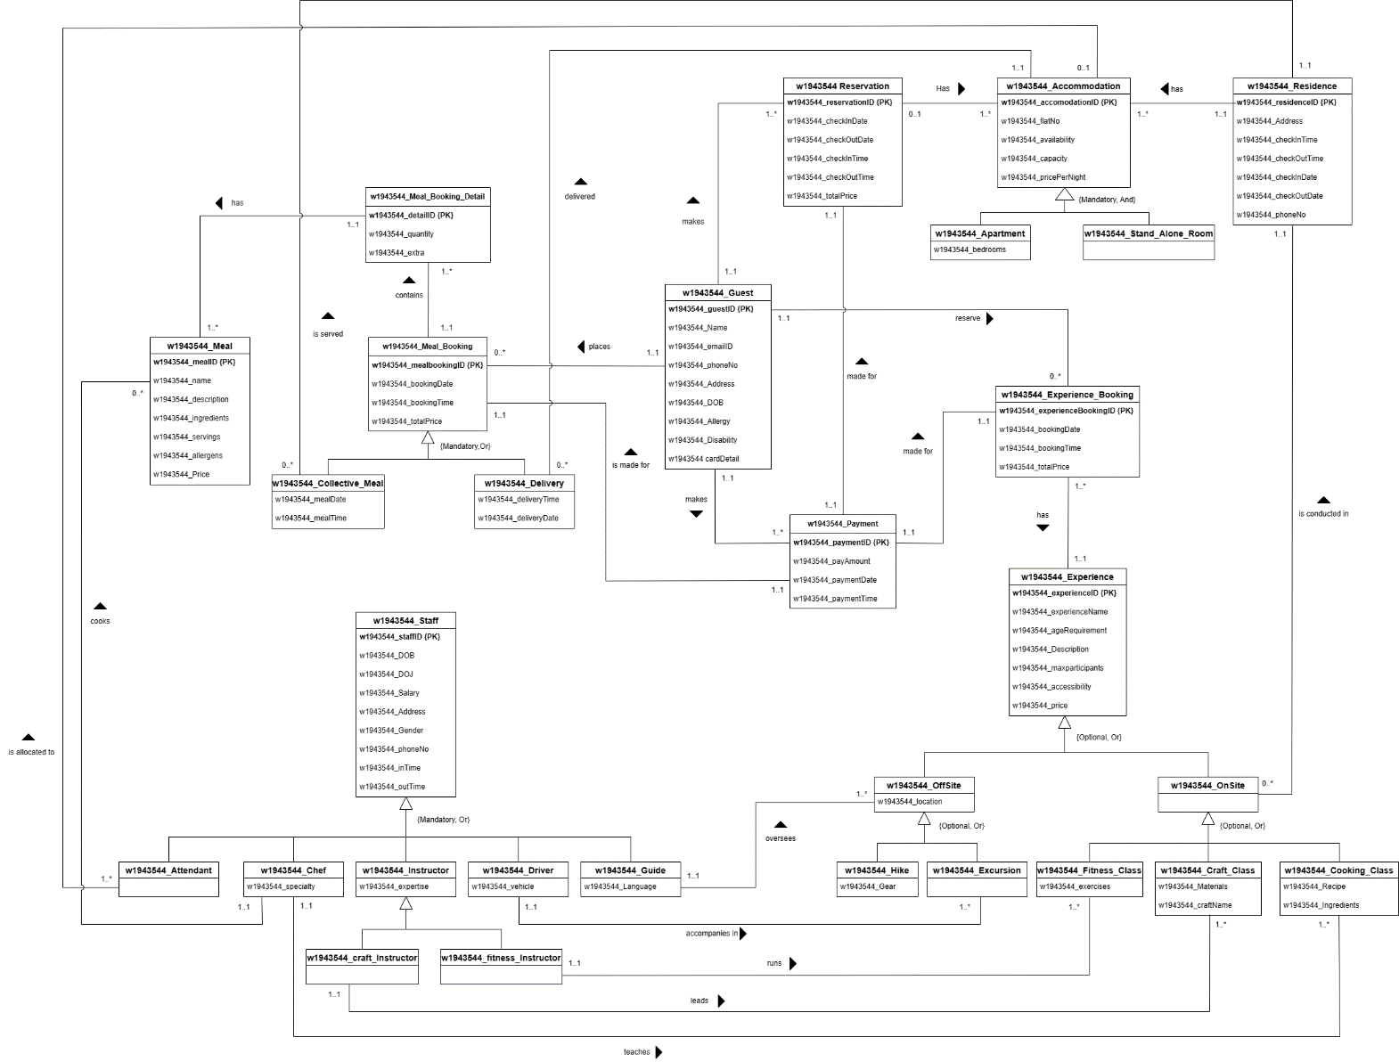

Part B: Question 7

